Health & Safety Policy
‾‾‾‾‾‾‾‾‾‾‾‾‾‾‾‾‾‾‾‾‾‾‾‾‾‾‾‾‾‾‾‾‾‾‾‾‾‾‾‾‾‾‾‾‾‾‾‾‾‾‾‾‾‾‾‾‾‾‾‾‾‾‾‾‾‾‾‾‾‾‾‾‾‾‾‾‾‾‾‾‾‾‾‾‾‾‾‾‾‾‾‾‾‾‾‾‾‾‾‾‾‾‾‾‾‾‾‾‾‾‾‾‾‾‾‾‾‾‾‾‾‾‾‾‾‾‾

Swish Building Products is committed to preventing injury and ill-health that may arise as a result of its undertakings. To ensure compliance with all relevant H&S legislation, to follow a programme of continuous improvement and to ensure we consider the needs and requirements of our stakeholders, the Company will operate an Integrated Management System (IMS) in accordance with ISO 45001:2018 and with the requirements of the Epwin Group Health & Safety Policy Document.

The Company board members are ultimately responsible for implementing the health and safety policy. The Managing Director shall ensure, with the help of the management team, that the policy is communicated and implemented across the business and to all relevant parties.

Employees are responsible for their own health and safety and that of the people they work with. They are expected to adopt and maintain a responsible attitude to safety and to carry out their duties in a safe and professional manner. In particular the company encourages its employees to report hazards in order to maintain a proactive approach to risk management.

The senior Management of Swish Building Products is committed to:

- Continually review, update and improve the IMS.
- Establish OH&S objectives throughout the business, and maintain these as part of the IMS internal auditing, monitoring and management review processes.
- Fulfill its legal and other obligations.
- Continually improve health and safety performance. To achieve this, the company will, as far as is reasonably practicable, actively identify, reduce and eliminate OH&S risks and hazards.
- Provide and maintain plant and facilities that are safe in order to minimise risks to the health, safety and welfare of employees and others.
- Develop and communicate procedures and safe systems of work to ensure activities are carried out in a safe manner.
- Consult, communicate and encourage the partication of its employees via the joint consultative committee (JCC), health and safety committee and the union representatives.
- Produce an annual occupational health & safety plan that will contain prioritised objectives based on the outcome of incident analysis and systems audits.

This policy will be periodically reviewed and amended when necessary.

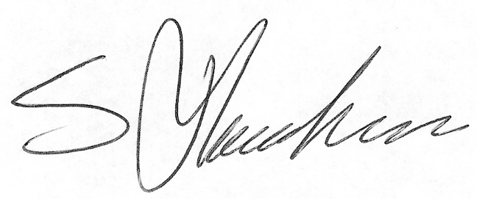
________________________
SHAUN HANRAHAN
Managing Director

